World war II Causes:
The 1930s brought international instability as the Lague of Nations appeared powerless in the face of such threats to world peace as:
- 1930 Japan invaded Manchuria to secure cool and iron China protested to League which simply condemned Japanese invasion.
- 1933 Japan and Germany withdraw from League of Nations.
- 1935 Italy invaded Abyssinia (Ethiopia). Feeble response from league.
- 1936 German troops marched into demilitarized Rhineland (violation of Versailles treaty). France appealed to Great Britain for support > No support > Hitler perhaps convinced of Britain's weakness.
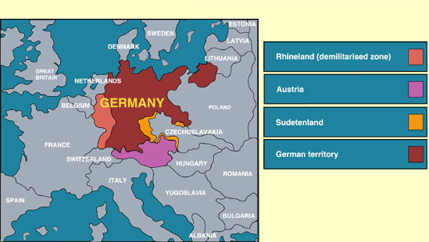
Map of the Rhineland
- 1936 Spanish civil war (Germany and Italy sent military aid to France who was fighting communism).
- 1937 Japan, who had formed a pact with Nazi Germany 1936, launched full-scale invasion of China.
*Note: The absence of the United States from the League and the withdrawal of Germany and Japan from the League in 1933 seriously weakened the League of Nations. The USSR did not join until 1934.
SCO 3.1 Delineation 3.1.1
Pan-Germanism: German nationalist doctrine aiming at the union of all German-speaking peoples under German rule. Lebensraum ( in English, means " living space " ). Adding living space was believed to strengthen Germany by helping to solve internal problems, make its military stronger, and help make Germany become economically self-sufficient by adding food and other raw material sources.
Hitler looked east for Germany's expansion in Europe. It was in this view that Hitler added a racist element to Lebensraum. BY stating that the Soviet Union was run by jews, then Hitler concluded Germany had a right to take Russian land.
Thus, in Nazi ideology, Lebensraum meant the expansion of Germany to the east in search of a unity between the German Volk and the land ( the Nazi concept of blood and soil ). The Nazi modified theory of Lebensraum became Germany's foreign policy during the Third Reich.
Without consideration of " traditions " and prejudices, it [ Germany ] must find the courage to gather our people and their strength for an advance along the road that will lead this people form it's present restricted living space to new land and soil, and hence also free it from the danger of vanishing from the earth or of serving others as a slave nation " - Adolf Hitler, Mein Kampf.
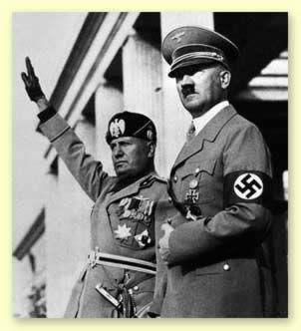
Benito Mussolini and Adolf Hitler
Anschluss: Union (Annexation) of Austria into the German Reich. The German term Anschluss (literally connection, attachment, inclusion) refers in specific political terms to the inclusion of Austria in a "Greater Germany" in 1938.
Sudetenland: The Sudenten is a historical region comprising areas of the Czechoslovakian provinces of Bohemia and Moravia, in the vicinity of the Sudeten Mountains. The majority of it's inhabitants were German speaking.
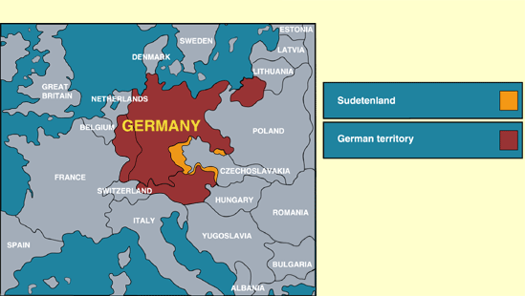
Map of Sudetenland
Nazi-Soviet Pact: 1939. Non-aggression pact signed by Germany and USSR. Both countries had a secret agreement to invade and divide Poland between them. Stalin: "Of course it's all a game to see who can fool whom. I know what Hitler's up to. He thinks he's outsmarted me, but actually it's i who have tricked him."
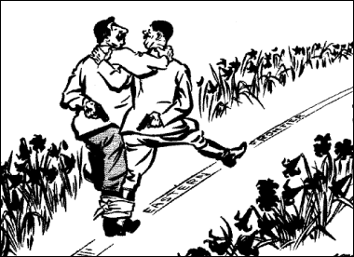
Cartoon showing how neither side trusted eachother. Notice the guns behind their back. Both sides were using eachother, the Soviets to buy time and Germany to avoid fighting on two fronts.
Munich Pact: a treaty concluded at the four power Munich conference of Sept. 29-30, by Neville CHAMBERLAIN and Edouard Daladier, prime ministers of Britain and France, and Adolf HITLER and Benito MUSSOLINI, dictators of Germany and Italy. The pact represented the high point of the policy of appeasement by Britain and France of Nazi Germany and Fascist Italy before WORLD WAR II. It's immediate result was the dismemberment of Czechoslovakia.
3.1.2 : There were two main military alliances on in WWI : The Axis and the Allies Axis L AKA the Berlin-Rome-Tokyo alliance. Consisted of Germany, Italy, and Japan. These three countries recognized German hegemony over most of continental Europe, Italian hegemony over the Mediterranean, and Japanese hegemony over East Asia and the pacific. Allies: First consisted of Great Britain and France. Later included USSR and USA.
3.1.3 : There were may threats to world peace in the 1930's. For notes on the Japanese invasion of Manchuria and the Italian invasion of Ethiopia, please refer to the handout given to you in an earlier class. Other examples include :
- German rearmament 1935: German rearmament began after Hitler left 1932-4 Geneva Disarmament Conference, stating that as the powers would not disarm to his level, he would ream Germany to their level. By 1935 rearmament was well underway. This involved conscription and munitions factories. Although this violated the Versailles treaty, nothing was done to stop Germany.
- German occupation of the Rhineland 1936: According to the treaty of Versailles, Rhineland (between France and Germany) was to be a demilitarized zone. Prior to the Versailles treaty, this region had belonged to Germany. In March 1936, Hitler moved to reclaim the Rhineland , and the League of Nations did nothing, because they felt that Germany was simply " marching into her own back yard. " This move was risky for they felt that Germany, because it could have started a war that Germany was nt prepared to fight.
- Japanese all-out war against China 1937: In the summer of 1937, Japan (which had already invaded the Chinese region of Manchuria) launched an all-out attack against many major cities in Japan. Once more, the league condemned Japan, but took no real action against it. The Japanese came up against a little organized resistance. The Chinese army put up little resistance though they were up against a formidable enemy. In November 1937, China's most important port, Shanghai, fell and Nanjing (Nanking), Chiang Kai-shek's capital, fell in December 1937. The onslaught of the Japanese was relentless. Within 5 months, 1 million Chinese people were under Japanese control. All of the major cities in chine were captured by the Japanese by the end of 1937 - so were the major communications systems of the nation.
3.1.4
Germany wanted to expand for several reasons:
- Hitler wanted to establish Germany as the dominant power in Europe. In his mind , a greater Germany meant an expanded Germany.
- Hitler felt that in order to house and provided for the expanding aryan population of Germany, they needed more lebensraum.
- Hitler wanted Germany to be more self-sufficient. Trade was not the answer because it would have meant German dependence on other countries. Hitler wanted Germany to be able to produce its own food, goods, and machinery without having to rely on materials from other countries.
- Hitler believed that Germans were the superior race, and should subdue and control "lesser" races i.e. Slavic peoples in eastern Europe. Hitler believed in the "might is right" principal.
3.1.5
Appeasement: the policy of granting concessions to potential enemies to maintain peace.
Some view it as "giving in to a bully". In terms of German expansion, appeasement means that when Hitler set his sights on expanding in to Czechoslovakia, Britain and France appeased him by offering him the Sudetenland region of Czechoslovakia, instead of the entire country. They felt that Hitler would be content with this, and hoped he would not act aggressively towards other nations Appeasement was also practiced by members of the league of nations when they did little to punish Japan for invading Manchuria, and Italy for invading Ethiopia.
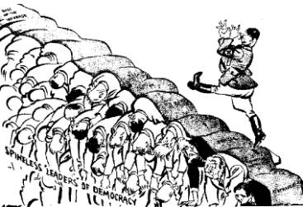
Cartoon showing how Hitler walked over democratic countries such as Britian and France.
Britain and France were prepared to follow a policy of appeasement for a number of reasons:
- The memories of WWI were still fresh in the minds of many Europeans. They wanted to avoid another war at all costs.
- The Western world was still caught in the Great Depression, and they simply lacked the money needed to fight another war.
- Political opinions in Britain and France was deeply divided among those who felt that fascism/Nazism was a bad thing, and those who felt that it was a useful tool in containing Communism. The result was political paralysis.
3.1.6 In general, appeasement was not effective in containing the territorial expansion of Nazism. Hitler greatly took the Sudetenland as it was offered to him at the Munic Conference, and then went to invade the rest of Czechoslovakia, and finally Poland, the event which precipitated the war.
3.1.7 In class, we studied documents relating to appeasement, some of which were written by Churchill, and some by Chamberlain. In general Chamberlain was pro-appeasement. He was a rationalist who believed that rational men could fix any problem by sitting down and having a civilized discussion about it. Churchill, who became Prime minister in 1940, had been against appeasement from the start.
"It is total defeat. Czechoslovakia will be swallowed up by the Nazis. And do not suppose that this is the end. This is only the beginning" Winston Churchill, speaking about the Munich Agreement, 1938.
"We should seek by all means in our power to avoid war, by analyzing possible causes, by trying to remove them, by discussion in a spirit of collaboration and good will. I cannot believe that such a program would be rejected by the people of this country, even if `it does mean the establishment of personal contact with the dictators." Neville Chamberlain.
3.1.8 Britain and France ended appeasement when Hitler demanded to expand into Poland mainly because they realized that they had been fooled by Hitler at the Munic Conference. They saw that Hitler was going to try to take whatever he wanted, and that negotiations would not satisfy him.
The Abyssinian Crisis 1935-36
This way the second major crisis in the 1930's. In 1935 Italy invaded Abyssinia. Once again, the League failed to stop aggression.
Why did Italy invade?
In the 1930's Abyssinia (now Ethiopia) was the only independent black African state. It was ruled by Emperor Haile Selassie.
Mussolini, the Italian dictator, invaded for several reasons:
- Italy had suffered from the Great Depression and unemployment rose.
- Mussolini turned to foreign conquest to distract the attention of the Italian people.Italy already had an empire in the north-east Africa, the colonies of Eritrea and
- Italian Somaliland which were on the borders of Abyssinia.
- The Italians had already tried to take Abyssinia in 1896. They had been defeated at the battle Adowa. This was the chance for revenge.
- Mussolini was jealous of Hitler's rearmament in Germany. He wanted to show that he was still the main dictator in Europe.
Profile on Benito Mussolini
Mussolini was a journalist before the First World War. He fought and was angry at how little Italy gained in the peace treaties. He set up his own party, known as the Fascists, and in 1922 organized a march in Rome which made him prime minister. He soon made himself dictator of Italy and wanted success abroad to boost his popularity.
Source A
Mussolini explains why he invaded Abyssinia
It is not only our army which marches into Abyssinia. 44 million Italian's march with that army, all united and alert. When, in 915, Italy joined with the Allies against the Central Powers, how many promises were made? Italy lost 670,000 dead and 480,000 disabled and more then a million wounded. When we went to the peace negotiations, we were only given crumbs.
The Invasion
In December 1934 Italian troops provoked a clash with Abyssinians at Wal Wal as an excuse for war. In October 1935 Italy invaded. The Abyssinian forces stood little chance against the modern Italian army. Nevertheless it was a huge country with poor roads and took a long time to conquer.
Source C
Why did the League fail?
The League failed for several reasons:
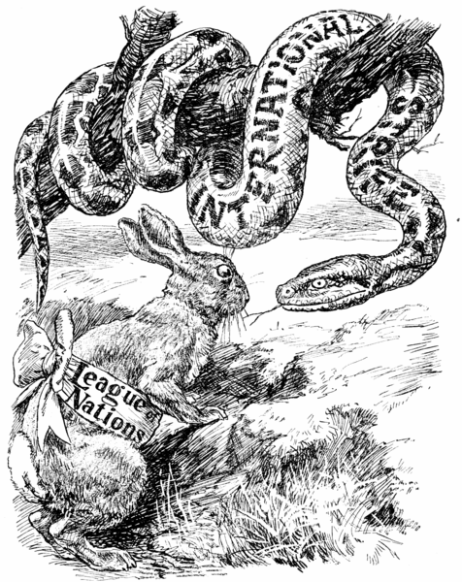
This cartoon is showing how the Leage of Nations was powerless in stopping "International strife."
- Members were unwilling to impose economic sanctions on Japan because the Depression had already damaged world trade and this would damage it further
- The great powers were unwilling to take military action. Britain, especially, feared Japanese attacks on its colonies in the Far East
- The USA was the most powerful country with interests in the Far East. It sent Representatives to join the Lytton Commission but was not prepared to take any further action.
Results of the crisis This had several results:
- It was the first major failure of the league of power. It showed that it was weak in the face of great power.
- The world learnt that it paid to be aggressive. It encouraged further acts of aggression such as Italy in Abyssinia.
- Japan continued its aggression. It took over more provinces in north China between and 1936.
- The Japanese withdrew from the league and eventually drew closer to dictators such as Mussolini and Hitler. It formed the anti-comintern Pact with Germany and Italy, between 1936 and 1937.
What did the league do?
The league tried various actions all of which failed.
- December 1934 The League offered to arbitrate (act as a judge) in the dispute. Rejected by Italy.
- October 1935 Emperor Haile Selassie appealed to the League for help. The League:
  - Condemned the Italian invasion of Abyssinia.
  - Imposed economic sanctions on Italy but these did not include oil, coal, and iron. Non league members such as the USA and Germany continued to trade with Italy. Mussolini later admitted that if they had not it would have stopped the invasion in a week.
  - December 1935 The Hoare-Laval Pact. This was drawn up by the foreign secretaries of Britain and France, Samuel Hoare and Pierre Laval. Large areas of Abyssinia were to be given to Mussolini in return for troop withdrawal. Abyssinia would be reduced to half its original size. Almost immediately details were leaked to the press, causing a public outcry. The plan was abandoned.
  - March 1936 Threatened oil embargo on Italy. This had no impact. The Italians conquered Abyssinia and united it with Eritrea and Somali land.
  - June 1936 Haile Selassie addressed the Assembly calling for League assistance against Italian aggression. No additional League action.
  - July 1936 Sanctions against Italy abandoned.
Why did the league fail in Abyssinia? Successful action against Italy was dependant on Britain and France. They were unwilling to take strong measures because:
- They were frightened that if they imposed full sanctions it would lead to war with Italy. They were not ready for a war.
- They wanted to keep Mussolini as an ally. They did not want to upset him as this might drive him to ally with Hitler and Germany.
- Their attempt at a compromise, the Hoare-Laval Pact, showed Mussolini how weak they were. He therefore continued the invasion.
Results of the Crisis once again, it showed the weakness of the League. Countries lost faith in the League and its ideals. Several countries, including Britain and France, moved away from their policy of collective security and began to rearm.
The actions of the League and Britain and France upset Mussolini. He did not expect them to oppose his invasion. He moved closer to Hitler and in 1936 signed the Rome-Berlin Axis. Once again, aggression had been shown to work. Hitler took note of this lesson. In 1937 Italy left the league.
Questions:
- What reason does Mussolini give in Source A for the Italian invasion? (See page 140)
- What reason is suggested in Source B for Italian success in Abyssinia?
- Explain the Hoare-Laval Pact. Why did it fall?
- Is Source C for or against Mussolini? Explain your answer.
Why did the League of Nations fail? The League failed for several reasons:
- The organization of the League contained weaknesses. The League did not meet frequently so there were delays.
- Important nations were absent. The USA never joined. Germany did not join until 1926 and left in 1933. Japan left in 1933 and Italy in 1937. The Soviet Union did not join until 1934 and was expelled in 1939.
- Sanctions were ineffective, especially without the USA as a member.
- The League did not have its own military forces to use against an aggressor.
- Countries were often reluctant to act unless their own interests were at stake and sometimes even acted against League decisions. The Hoare-Laval Pact in Abyssinia is one such example.
Questions:
- What is the meaning of what Mussolini says in Source A?
- Which do you think was the most important reason for the failure of the League? Why?
- Do you think the League was a total failure?
SCO-3.2
Students will be expected to draw upon primary and/or secondary sources to demonstrate an understanding of the events of WWII.
3.2.1
Definitions
BLITZKREIG: "Lighting War" in German. Blitzkreig was used to describe the tactics successfully used by the Germans early in the war.
The aim of Blitzkreig was to paralyse the enemy by a devastating use of the most up-to-date technology and clever military tactics. Blitzkreig was based on two weapons-the areoplane and the tank. It depended on the surprise, speed and weight of forces and followed the following pattern:
- Bombers attacked enemy airfields and communication centers. This was to prevent any resistance from enemy aircraft and to slow down enemy reinforcement.
- Parachutists were dropped behind enemy lines to capture bridges and other important targets and further disrupt communitcations.
- Dive bombers moved ahead of the tanks and attacked enemy strong points
- Tanks broke through weak points in the enemy lines and travelled fast across country and outflanked the enemy front lines.
- Mortorized infantry followed to mop of resistance.
The Blitzkreig proved a very successful tactic because:
- It was a new and unexpected tactic. The Allies, especially Britain and France, believed it would be a war of attrition like that of 1914-18. For this reason they remained on the defensive in the early months of the war.
- It was carried out very quickly and did not give the enemy an opportunity to recover.
- The Germans used their tanks in large groups in a few places as a spearhead for attacks. Although the British and French had lots of tanks, they divided them into small groups and spread them around their lines.
- The French felt safe from German attack because of the Maginot Line. (see definition)
- See diagram of Blitzkreig.
Maginot Line: A line of bombproof cement and steel fortifications that contained heavy artillery that the French had built in the 1930's. It stretched from along the French-German border from Switzerland to Belgium. The line was designed to prevent a German attack on France. The French believed it was impossible for any invading army to break through this series of forts, which were linked by underground tunnels.
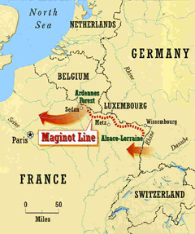
Map showing the Maginot line
Phoney War: The name given to the period form the end of September 1939 to April 1914, when, although war existed between Germany and Britain and France no actual combat between their armies took place. There was limited naval engagements between Germany and Britain, but little progress was made in the war in the west.
Britain and France prepared for the war during this period and a British force (BEF) was sent to France to support the French. But the military preparations were half-hearted because the French felt safe from attack due to the Maginot Line.
The British and French ignored the lessons of the Blitzkreig in Poland and made no preparations to deal with this new tactic.
Kamikazes : Japanese `suicide pilots' of World War II who flew suicidal missions by heading their airplanes laden with explosives into an enemy ship or other targets.
3.2.2
Assess the early success of Germany in the first year of the war.
Germany was able to achieve great success in the war in the west for a number of reasons:
- Blitzkreig: The French, British, Belgian. And Dutch armies were overcome by the speed and weight of the German attack.
- German Superiority in Equipment
  - Germany had ten armoured divisions the allies only had four.
  - The Germans had 4000 aircraft to the allies' 1400
- Allied Weaknesses:
  - The Allies did not have one overall commander.
  - They went on the defensive in the winter of 1939-1940 (Phoney War) and made no preparations to deal with Blitzkreig.
  - The Allied commanders wrongly believed it would be a war of attrition.
  - They scattered their tanks all over the Western Front instead of concentrating them against the German attack.
- German advantages:
  - They had a commander and a plan of attack.
  - Hitler was free to flight on one front only after the defeat of Poland.
  - The Germans attacked France through thye Ardennes and outflanked the Maginot Line.
As a result of these reasons Germany was able in 1939-1940 to have captured:
- Poland in September of 1939.
- Denmark in April of 1940.
- Norway in April and June of 1940.
- Luxembourg in May of 1940.
- The Netherlands in May of 1940.
- Belgium in May of 1940.
- France in June of 1940.
3.2.3
Reasons why Britain was able to survive the Battle of Britain were:
- British Radar: In the mid 1930's Britain had developed a sophisticated defense system against enemy bombing. This system was based around radar. Having radar prevented the RAF suffering the same fate as the Polish Air Force when it was attacked by the Luftwaffe before it got into the air. Radar stations made it possible to track approaching enemy planes from their starting points, and so concentrate the defense just where it was needed. British fighter planes were often in the skies above and the German plans as they arrived over Britain. This gave them a tactical advantage.
- The British Possessed the ULTRA: the key to Germany's radio codes which meant that British/RAF had advanced warning to German plans.
- The RAF fighter planes: the Hurricane and the Spitfire - were a good match for their German counterparts - the Messerschmitt Me109 and the twin-engined Messerschmitt Me110 which was unsuitable for dogfights with British fighter planes. The Me109 lacked the fuel capacity to be able to stay very long over south-east Britain although it was an excellent fighter plane.
- The RAF were fighting over thewir own territory: This meant that British pilots that were shot down and survived could be sent bacl into combat.
- The RAF were led by Air Chief Marshall Sir Hugh Dowding who had been planning Britain's air defence system since 1936 and had brought in many important technical developments (e.g. bulletproof windscreen for fighter planes). he had also introduced command and communication systems which meant that RAF fighters could be quickly and effectively directed to meet enemy attacks.
- The mistake made by the German Luftwaffe's Goring when the diverted Lutwaffe attacks from RAF airfields and factories to concentrate on bombing British cities. This gave RAF time to repair airfields and repair factories and a much needed time to regroup when they were so close to being overwhelmed.
- Churchill's leadership and the strong British morale:Even when the Luftwaffe concentrated its attacks on British cities (THE BLITZ), they failed to destroy British morale, instead they made it stronger.
3.2.4 Describe the impact of the following key battles on the outcome of World War 2
DUNKIRK EVACUATION : - MAY 26 - June 4, 1940
The evacuation of some 338,000 British and French troops from the beaches of Dunkirk was seen as a great psychological victory and morale booster form British people, who would be facing Germany alone after the fall of France.
Dunkirk was one or Hitler/Germany's mistakes or WW2 because the Germans failed to destroy the British Expeditionary Force (BEF) at Dunkirk when they had the chance to do so.
BATTLE OF BRITAIN:- July 1, October, 31,1940
The air battle fought over the southern England between the German Luftwaffe and the Royal Air Force. The German Luftwaffe attacked the defences of Britain in an attempt to destroy them before the planned German invasion of England- Operation Sealion. The battle was fought in five stages and with dioffering strategies used by the German Luftwaffe. The battle ended when Germany abandoned its invasion plans after losing 1,733 aircraft to the RAF loss of 915 fighters as they realized that they could not control the skies over England and the English Channel which would be crucial to Operation Sealion
The significance of the Battle of Britain was that it was one of the First Defeats Germany was to suffer. With England undefeated and still in the war, Germany had a potentail threat on its Western Frunt as it proceeded to incade Russia in
Operation Barbaross:- June 22, 1940.
The German invasion of the USSR probed to be one of the greatest mistakes that Hitler made in WW2. Operation Barbarossa became knows as a "Clash of the Titans." in spite of winning many early victories and inflicting hugh casualties in capturing hundreds of thousands of Russian soldiers, Germany was to beecentually defeated in this campaign by a combination of weather, Russian morale and determination, and a seemingly endless supply of Russian soldiers.
The significance of Operation Barbarossa was that it set in motion one of the greatest battles in history that became the beginning of the end of the war for Germany.
BATTLE OF EL ALAMEIN: -August- October 1942
The Battle of El Alamein in North Africa was a major turning point of the Second World War for the Allies. In the Battle of El Alamein British forces commanded by Field Marshall Bernard Montgomery defeated the German Africa Korps led by German Field Marshall General Erwin Rommel ( Known as the Desert Fox)
The battle of El Alamein was the beginning of Allied drive seized the North African coast. This allowed the Allies to use North Africa as the staging point for its invasion of Sicily and eventually Italy. It was also important because it kept the vast oil resources for the Middle East out of the hands of the German military.
BATTLE OF STALINGRAD: August 1942 - January 31, 1943
The significance of the Battle of Stalingrad was that for the first time Germany Military history a German Army Surrender in the field. This Defeat of the German Army at the Stalingrad Marked the beginning of Germany's Defeat in Russia. After Stalingrad the Germans are on the defensive and are being forced back out of Russia and Back towards Germany and eventual Surrender in 1945.
Battle of the Atlantic: - 1939 to 1944
The struggle for control of the sea routes around Great Britian during World War II. It lasted for the whole period of the war but was particularly severe between 1940 and 1943 when Allied convoys were attacked by U-boats Wolf Packs), armed surface raiders, and long-range aircraft. Allied countermeasures included the escorting of convoys by warships, and the use of special escort aircraft carriers, armed merchant cruisers, submarines, land-based air cover, radar, and the underwater detection device, Asdic. Air attacks were also made on enemy naval bases and, in conjuntion witgh the Royal Navy, on enemy war ships at sea.
The significance of the Battle of the Atlantic was that these convoys and teh supplies they carried were vital to the Allied war effort and these supplies eventually helped the Allies defeat Germany.
Battle of Midway - Battle of Coral Sea
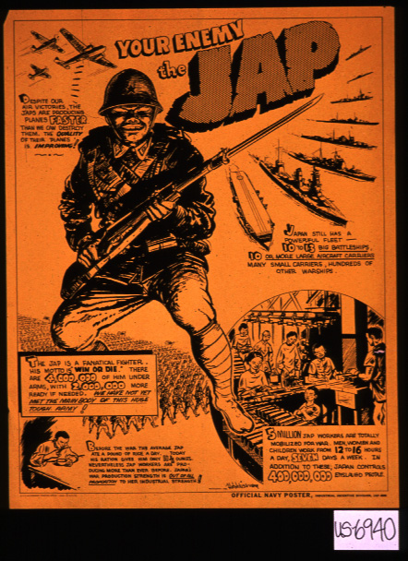
Propaganda poster showing the United States view of Japan
The battle of Midway was fought from June 3-6, 1942 between the US Naval and Air Forces and the Japanese Navy. In this battle the Japanese lost 4 aircraft carriers and 296 planes to the loss of one carrier and 132 aircraft for the Americans. The Battle of Midway put a decisiev halt to the string of Japanese victories and turned the tide against Japan.
The Battle of Coral Sea was fought from 4-8 of May 1942 between US and Japanese Naval Forces. This battle was won by the US and was significant because it stopped the Japanese invasion of the South Pacific and ensures the saftey of Australia.
These two battles severely weakened the Japanese Navy and Air Force and made it very difficult for them to properly defend or expand their emipre in the Pacific.
Before these two battles the Japanese are seemingly unbeatable in the Pacific Theatre of War, but after these two battles the tide turns in favour of the US and its Allies and Japan is on the defensive.
Normandy Invasion - D Day (Operation Overlord) - June 6, 1944
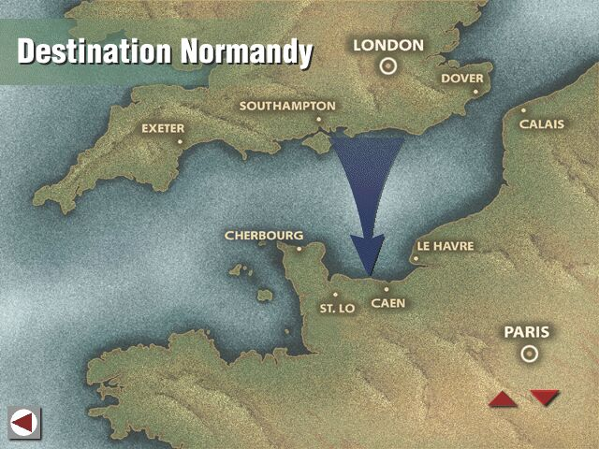
D-Day - June 6, 1944 was the start of the Allied invasion of Western Europe in World War II when British, Canadian, and US troops stromed five beaches at Normandy, France after being transported from Sothern England by the largest armada of ships in history, heavily protected by air and naval forces. After heavy fighting, breaches were made in the German positions (The Atlantic Wall) and the push across Western Europe began, rolling back the German army. Freeing occupied territory, and finally advancing into Germany itself.
The significance of D-Day was that now the Allies had opened the Western Front that was to take pressure off the Russians and force Germany to fight a war on two major fronts with its rapidly depleting resources of supplies and manpower.
3.2.5
Explain how the stationing of the American Pacific Fleet in Pearl Harbor, Hawaii and American sanctions against Japan strained Japanese-American relations prior to the Japanese attack on Pearl Harbor.
The stationing of the American Pacific Fleet in Pearl Harbor, Hawaii:
The positioning of the American Pacific Fleet in Pearl Harbor seriously strained American Japanese relations because the moving of the American Pacific Fleet from San Diego to Pearl Harbor directly threatened the expansionist policies of the Japanese in South East Asia and the Pacific.
American sanctions against Japan:
Japan had been at war with china since 1931, when Japanese troops took over Manchuria and in 1937, Japan had invaded southern China. US President Franklin D. Roosevelt was determined to keep Japan from taking over China. In addition, Japan threatened the American controlled Philippine islands, the British colonies of Singapore and Malaya, and the oil-rich Dutch colonies of the East Indies.
To put pressure on the Japanese, Roosevelt banned the shipment of American fuel, scrap metal, and steel to Japan. This loss of vital supplies made it difficult for Japan to continue its war with China. In July of 1941, Japanese forces overran French Indochina. Roosevelt retaliated by ordering a total embargo on all trade with with Japan. This embargo angered Japanese leaders, who after weeks of debate decided that if they could not persuade Roosevelt to end the embargo, they would attack the United States Pacific Fleet and then seize the Dutch East Indies and other areas of Southern Asia in order to obtain the much needed supplies needed for their planned creation of the Greater East Asia Co-Prosperity Sphere or Asia for the Asian(led by Japan).
3.2.6
Describe how each of the following factors contributed to American Military success over Japan:
- Size of American Fleet: The USA was able to produce more aircraft, aircraft carriers and other naval vessels (destroyers, cruisers, etc.) Than the Japanese. This capacity would in turn ensure that the balance of power favored the USA.
- More advanced technology:
  - The Americans had developed the Atomic Bomb.
  - The Americans had the B-52 Long- Range Bomber.
- Greater industrial strength:
  - The USA was almost completely self-sufficient in the resources needed for war.
  - The USA was able to produce military resources free from fear of Japanese attack on its industries.
  - The Japanese had awoken the "Sleeping Giant".
3.2.7
Analyze how the Americans entry into World War II affected the War's outcome.
- The American entry into the war meant that its Allies- Britain, Russia, and China- would benefit from its wealth, resources, and fighting forces.
- From 1941 to 1945 Hitler faced the two most powerful countries in the world.
- The American entry into the War meant that the War in Europe would receive priority over the War in the Pacific- thus ensuing Hitler's eventual defeat.
- With the defeat of Nazi Germany, the USA could then focus its military might against Japan.
3.2.8
Judge whether or not the dropping of the atomic bombs on Japan was justified:
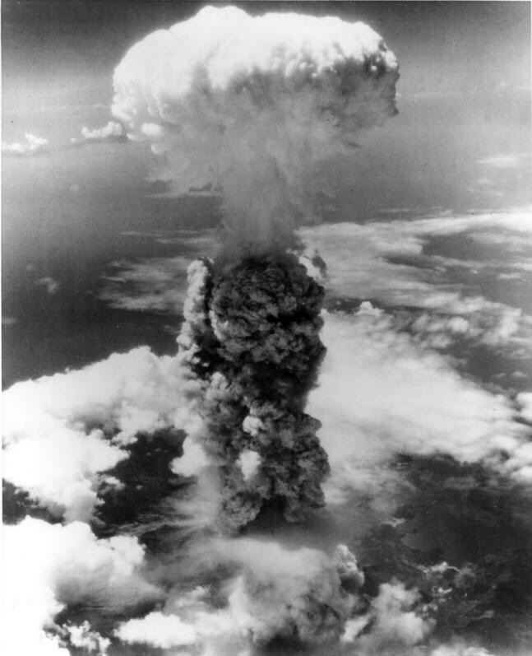
Atomic bomb explosion
Meanwhile Hirohito's generals, grimly preparing for the invasion, had not abandoned hope of saving their homeland. Although a few strategic islands had been lost, they told each other, most of their conquests, including the Chinese heartland, were firmly in their hands, and the bulk of their army was undefeated. Even though they could scarcely believe that any foe would have the audacity to attempt landings in Japan itself. Allied troops, they boasted would face the fiercest resistance in history. Over ten thousand kamikaze planes were readied for "Ketsu-Go" Operation Decision. Behind the beaches, enormous connecting underground caves had been Stocked with caches of food and thousands of tons of ammunition. Manning the nations ground defenses were 2,350,000 regular soldiers, 250,000 garrison troops, and more than 32,000,000 civilian militiamen- a total of 34,600,000, more than the combined armies of the United States, Great Britain, and Nazi Germany. All males aged 15 to 60, and all females aged 17 to 45, had been conscripted. Their weapons included ancient bronze cannon and, muzzle loading muskets, bamboo spears, and bows and arrows. Even little children had been trained to strap explosives around their waist, roll under tank treads, and blow themselves up. They were called "Sherman carpets."
Should the USA have used the atomic bomb?
Arguments for:
- The "war party" in Japan was still in control and had rejected peace terms.
- The Americans would suffer huge casualties if they tried to invade Japan. Many Japanese were prepared to fight to the death as a matter of honor. Japan still had 4 million troops and 4800 kamikaze pilots for suicide missions. Advisers told President Truman that if the war lasted until 1946 there would be at least one million more casualties.
- The USA and Britain feared Stalin intended to move into the Far East just as he had moved into Eastern Europe. The longer the war against Japan lasted, the more chance he would have. On August 8 Soviet troops attacked in the Japanese in Manchuria hoping to share victory with the USA.
- Normal bombing of Japanese cities would probably have brought more casualties than the use of the atomic bomb. The American bombing campaign between March and August 1945 had destroyed a quarter of Japanese houses in firebomb attacks
- The Japanese surrendered within a week of the second bomb being dropped.
- The cost of the project. The USA had spent millions of dollars developing the bomb. It had been successfully tested in July and was ready.
Arguments against:
- The Americans need not have dropped the bombs on mainly civilian cities. They could have attacked a military target or even demonstrated its destructive power on a waste area of Japan. This would have been enough warning to make the Japanese surrender.
- The "peace party" in Japan was known to want to discuss peace terms. The only stumbling block was the Allied refusal to guarantee the position of the emperor.
- Japan had already been defeated using conventional weapons. The atomic bomb made no difference.
- The atomic bomb was a terrible weapon to use. It caused appalling casualties both directly and through radiation sickness. When the Americans dropped the Atomic bomb on Hiroshima, at the very center of the explosion the heat was so great that anything caught in it turned from a solid to a gas. Further out, people were burnt alive. The explosion created a wind of 800 km an hour that crushed many people. But in many ways the worst damage was caused by radiation. It caused the flesh to dissolve and hang down in strips. 80,000 were killed, rising to over 138,000 as a result of radiation sickness. In Nagasaki, 40,000 were killed, rising to over 48,000.
- The atomic bomb was not dropped to force the surrender of Japan but as a warning to Stalin and stop the Soviet expansion in the Far East.
- It started a far more destructive Arms race in the years after 1945.
- It was one of the causes of the Cold War- Stalin.

